MAT 220 Statistics Homework solutions

Part II – Data Analysis and Application of Inferential Procedures

The following is an experiment whereby two categorical variables are used to define the treatments (groups) in an experiment (as opposed to one categorical variable in the one-way ANVOA and randomized complete block designs; although an additive two-way ANOVA is used for the latter to isolate the effect of the blocking variable). The researcher would like to determine if there is statistically significant evidence of an effect of either or both variables on the mean of the response variable. This particular experimental design is called a full-factorial (all combinations of the values of two groping variables are tested) and requires performing a two-way analysis of variance.

Run the R-script appended to the end of this assessment (and found in the FA18 MAT 220-W01 – Unit 2 Test (Part 2).R file, for your convenience) to generate the requisite output and use it to complete the analysis. While each part has been defined/organized to step you though the process of a performing a two-way ANOVA, you may find helpful, and in some cases necessary, to research the topic as well.

NOTE: Prior to running the R-script, you will need to load the dataset stored in the cash_offers.csv file (available on Blackboard). This can conveniently be done in RStudio by selecting Import Dataset > From Text (readr)… under the Environment window in the upper right, and then clicking on the Browse… button in the upper-right of the dialog box that appears to locate the downloaded aforementioned cash_offers.csv file. Once selected, click on the Import button on the lower-right; the default setting should be sufficient. If this is the first time using this feature in RStudio, the software may need to install packages/libraries (which is done automatically and won’t be repeated the next time around).

- [50 points] A consumer organization studied the effect of age and gender of automobile owner on size of cash offer for a used car by utilizing six male and six female volunteers in each of three age groups (young, middle, elderly) who acted as the owner of a used car. A medium price, six-year old car was selected for the experiment, and the “owners” solicited cash offers for this car from 36 dealers selected at random from the dealers in the region. Randomization was used in assigning the dealers to the “owners”. The offers (in hundred dollars, so 21 = $2,100) follow below. Due to limited space, the two-way table is split across the three values of the Age variable.

 | Gender |  |  |  | Gender |  |  |  | Gender
Age | Male | Female |  | Age | Male | Female |  | Age | Male | Female
Young | 21 | 21 |  | Middle | 30 | 26 |  | Elderly | 25 | 23
Young | 23 | 22 |  | Middle | 29 | 29 |  | Elderly | 22 | 19
Young | 19 | 20 |  | Middle | 26 | 27 |  | Elderly | 23 | 20
Young | 22 | 21 |  | Middle | 28 | 28 |  | Elderly | 21 | 21
Young | 22 | 19 |  | Middle | 27 | 27 |  | Elderly | 22 | 20
Young | 23 | 25 |  | Middle | 27 | 29 |  | Elderly | 21 | 20

  - [7 points] Identify the two factors (grouping variables), their respective number of levels (unique values each variable can take), the number of treatments, the number of replications within each cell, and the total number of measurements in the experiment.
Solution
Gender-two levels (male, female)
Age-three levels (young, middle, elderly)
Six number of treatments
Two replication in each cell
36 number of measurements

  - [8 points] In this context, explain what it means if (i) the main effect for Age is present (i.e., statistically significant evidence) and if (ii) an interaction effect (between Age and Gender) exists. You will likely need to research these topics for a two-way ANOVA, however, as an example, the explanation of the main effect for Gender is provided below for your reference.
If a main effect for the Gender factor were present, the mean cash offer for at least one of the groups, for example, “Male”, would be different than that of the others. Since there are only two levels for this variable (Male, Female), a significant main effect would indicate that the mean cash offer differed between males and females.
Further, an interaction effect exists if the trend observed for the main effect of one factor does not hold for each level of the other factor.

Solution
If a main effect on age exists or ie statistically significant evident , the mean cash offers of at least one groups( young, middle or elderly) would be different from that of others.
If the interaction effect between age and gender existed then it would suggest that the mean cash offers of the groups differed.

  - [6 points] The requirements to perform a two-way analysis of variance are the same as that of a one-way, just extended to a second grouping variable – so [typically] more treatment groups to compare. Explain how/if each one is met.

Solution
1.Test for normality
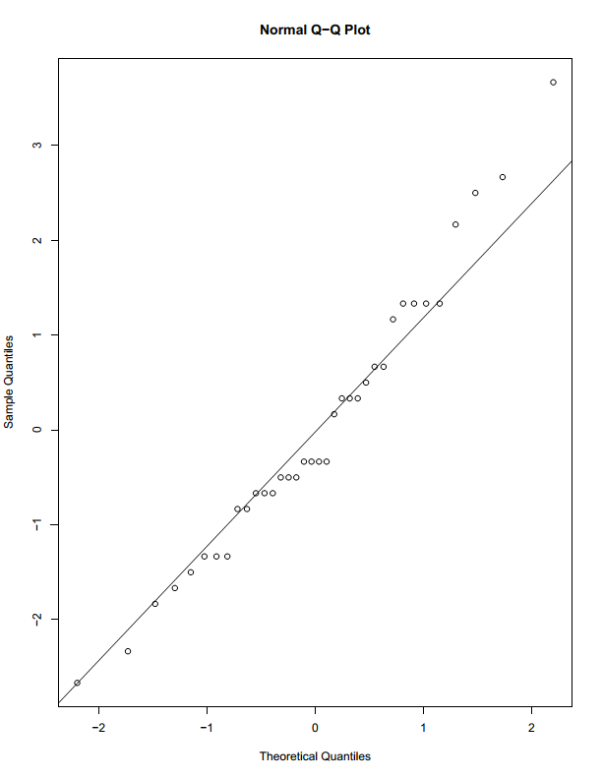

Most points fall close to the normal line. This shows that the data is most likely to follow a normal model.
2.Test samples are independent from each other. Hence fulfils the condition of sample independent.

  - [15 points] In a two-way ANOVA, there are three separate overall F tests conducted (as opposed to a single overall F test for a one-way ANOVA) prior to any potential pairwise comparisons being consider in the post-hoc analysis. We start with testing if an interaction effect is present and then look at each main effect. If there is no significant evidence of an interaction between the two factors (on the mean response), this greatly simplifies any potential further analysis of the main effects as we can then just look at their respective impact (if any) on mean of the response variable independently. Below are two of the three hypotheses to be tested, specifically the interaction effect, and main effect due to Gender. Write the null and alternative hypothesis for the main effect due to the Age factor and then use the appropriate information in the ANOVA table to perform each test; that is, determine if there is statistically significant evidence of (i) an interaction effect, (ii) a main effect due to Age, and (iii) a main effect due to Gender on the mean cash offer. For each F test, explain how you came about your decision and write your conclusion in context.
NOTE: In the ANOVA table, the interaction coefficient (term) is listed as the product of both factors (column names for grouping variables).

INTERACTION EFFECT (Age*Gender)
$H_{0}:$ There is no interaction between the levels of Age and Gender.
$H_{1}:$ There is interaction between the levels of Age and Gender.

MAIN EFFECT (Gender)
$$H_{0}:μ_{Male}=μ_{Female}$$
$H_{1}:$ at least one $μ_{i}$ differs, where $i$ = Male, and Female

$μ_{i}$ represents the mean cash offer for the $i$ gender.

Solution
Analysis of Variance Table

Response: offer
Df Sum Sq Mean Sq F value Pr(>F)
age 2 316.72 158.361 66.2907 9.789e-12 ***
gender 1 5.44 5.444 2.2791 0.1416
age:gender 2 5.06 2.528 1.0581 0.3597
Residuals 30 71.67 2.389
---
Signif. codes: 0 ‘***’ 0.001 ‘**’ 0.01 ‘*’ 0.05 ‘.’ 0.1 ‘ ’ 1

Gender and Age:

Decision: The p-value 0.3597 is greater than 0.05 therefore we do not reject the null hypothesis.
Conclusion: At the 5% significance level there is no statistically significance evidence of interaction between age and gender. Hence there is no interaction between age and gender.

Age:

Decision: The p-value 9.789e-12 *** is less than 0.05 therefore we do reject the null hypothesis.
Conclusion: At the 5% significance level there is statistically significance of interaction evidence between age and cash offers.

Gender:
Decision: The p-value 0.1416 is greater than 0.05 therefore we do not reject the null hypothesis.
Conclusion: At the 5% significance level there is no statistically significance of interaction evidence between gender and cash offers.

  - [8 points] For each significant main effect, use results from Tukey’s HSD simultaneous tests and confidence intervals to determine which pairwise means differ using a familywise error rate of 5%. Briefly summarize your findings both symbolically and literally in context. When applicable, use the simultaneous confidence intervals to estimate any significant differences in the mean cash offer.

Solution
Tukey multiple comparisons of means
95% family-wise confidence level

Fit: aov (formula = offer ~ age + gender + age * gender, data = cashofferss)

$age
diff lwr upr p adj
middle-elderly 6.33333333 4.777772 7.888894 0.0000000
young-elderly 0.08333333 -1.472228 1.638894 0.9904333
young-middle -6.25000000 -7.805561 -4.694439 0.0000000

$gender
diff lwr upr p adj
male- female 0.7777778 -0.2744031 1.829959 0.141592
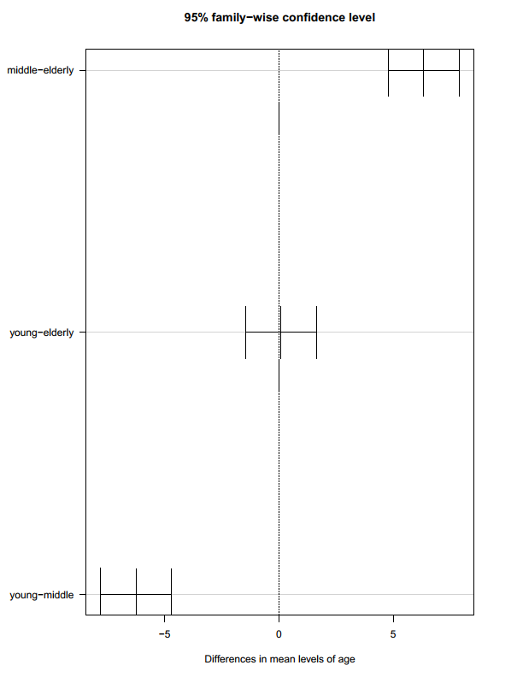
Symbolically:
The comparisons of p adj that are bolded in blue implies that there is significant evidence that the comparison are large. However the evidence of the two is the same.
Mean of young=mean of elderly.

Literally:
We are 95% confident that the main effect age has a statistical significant evidence effect on cash offers. The young and elderly proves to have more effect as compared to the middle.

  - [6 points] An interaction plot is a useful instrument to visually compare the observed sample (group) means for each of the respective treatment levels in the experiment in order to determine if any potentially significant interaction and/or main effects are present. The vertical axis typically represents the [sample] mean response (cash offer), while the other [horizontal] axis identifies the levels for the first listed factor (grouping variable) and separate lines are defined for the various levels of the second listed factor. Roughly parallel lines suggest no significant interaction between the two factors exists , while significant changes in the observed mean response as we move across the levels of each factor (either left-to-right, if the first factor, or top-down if the second) indicates evidence of one or both main effects. Using either of the interaction plots generated by the RScript for this experiment – they convey the same information, just switch the organization/presentation of the two factors - explain how it supports (or possibly refutes) your findings/conclusions.
Solution

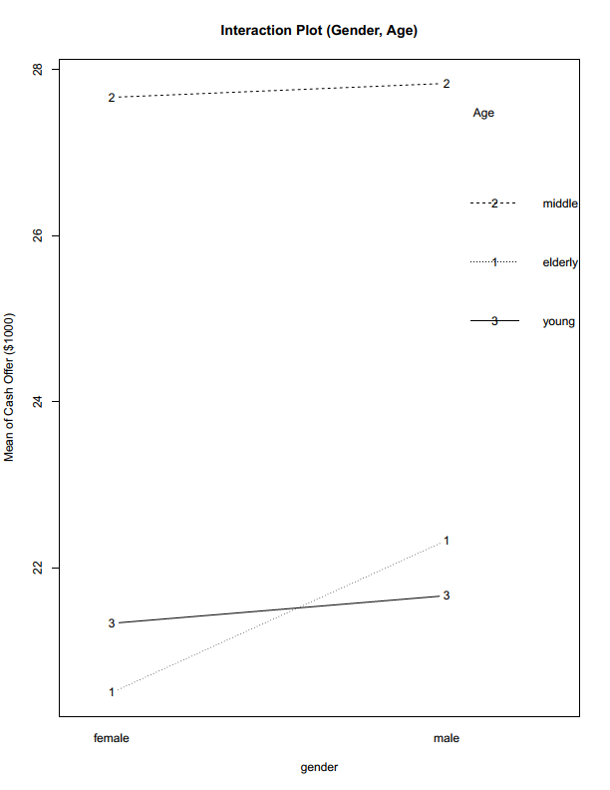
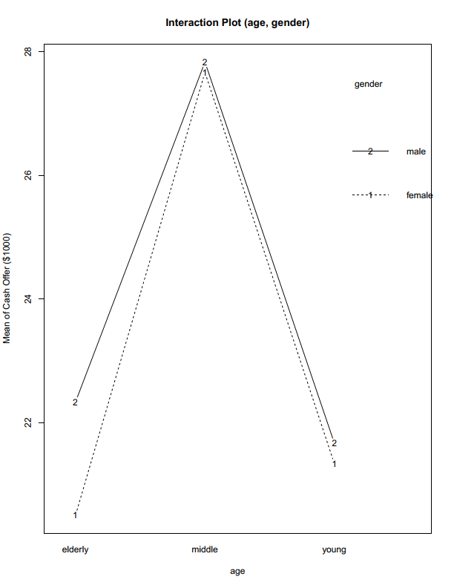
According to the interaction plots there is there exists no interaction between the two factors that is age and gender.
R Code

Part II - Problem 1

# load data set

# Use the 'Import Dataset' option under the 'Environment' window
# and store in data.frame object named 'offers'

# generate summary statistics by group
summary.by <- function(x, group)
{
data.frame(
mean = tapply(x, group, FUN=mean),
sd = tapply(x, group, FUN=sd),
n = tapply(x, group, FUN=length)
)
}

summary.by(cash_offers$Offer, cash_offers[-3])

# perform the analysis and capture the output
fit <- aov(Offer ~ Age + Gender + Age*Gender, data=cash_offers)

# construct the normal probability plot of the residuals
qqnorm(fit$residuals)
qqline(fit$residuals)

# print the ANOVA table
anova(fit)

# construct interactions plot(s)
interaction.plot(
x.factor=cash_offers$Age, trace.factor=cash_offers$Gender,
response=cash_offers$Offer,
xlab="Age", ylab="Mean of Cash Offer ($1000)", trace.label="Gender",
main="Interaction Plot (Age, Gender)", type="b"
)
interaction.plot(
x.factor=cash_offers$Gender, trace.factor=cash_offers$Age,
response=cash_offers$Offer,
xlab="Gender", ylab="Mean of Cash Offer ($1000)", trace.label="Age",
main="Interaction Plot (Gender, Age)", type="b"
)

# generate Tukey HSD CIs and P-values
tukey <- TukeyHSD(fit, which=c("Age","Gender"), conf.level=0.95)
print(tukey)

# plot Tukey HSD CIs
par(mar=c(5,7,4,4), las=1)
plot(tukey)

